➢➢ Explanation :
- One’s complement of number means to invert each bit of that number. So our task is to complement each bit of number.
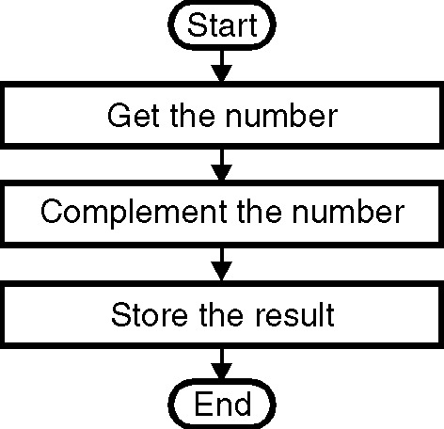
- We will first load the number whose 1’s complement is to be found in the accumulator.
- Using the CMA instruction we will complement the accumulator. This is 1’s complement of the number.
- Store the result at memory location C100 H.
➢➢ Algorithm :
Step I : Get the number
Step II : Complement the number
Step III : Store the result.
➢➢ Flowchart : Refer flowchart 9 Flowchart 9
➢➢ Program :
Instruction Operation Comments
LDA C200H ; C200 → A ; Get the number
CMA ; –→ A ; Complement number
STA C100H ; ; Store the result
HLT ; Stop ; Terminate program execution

